Rent The Runway Warehouse Operation

Optimizing the process time to ship on time

Mami Takeuchi

11/19/2019

Table of Contents

Executive Summary 3

Introduction 3

List of Modules 4

Research Description 5

Diagram of the process 5

Input Analysis 5

References 7

# Executive Summary

# Introduction

Rent the Runway is a fast growing company who provides a service to rent the luxury brand for 10 percent of its retail price. Customers find the item what they like on their website, and reserve the item. The items are shipped within two days and the customers can ship the item back after the renting period ends. The company was founded by two Harvard graduates in 2009, and the company now valued at over 1 billion. According to their website, their success is based on their warehouse operation. However, the complains on their shipment delay are increasing and their operation does not seem to be great as they did before.

They have a warehouse in Secaucus, NJ where all the returned items arrive and the repair, cleaning, taking new orders, and shipping process are done. According to their official website, average turn around time for their inventory is one day. Their facility opens 24 hours per day, Monday through Saturday. All of Rent the Runway’s returns start flowing into its facility between seven and 11 a.m. Shipment has to be out by 3 pm. Their goal is to ship all the returned item on the same day. However, only 50% of the returned item are shipped on the same day in the current operating system. In fact, as the company grows, they receive more orders, and delays in shipment occurred. In the recent news reported that they have more complains these days.

After the return items arrives, it will go to quality check process to decide if the repairment was necessary. This process takes 30 seconds. After the item is passed the quality check, it will go to cleaning process. After cleaning, the item goes to iron section and covered with a plastic bag and stowed. When a new order comes in, the item was found and matched by a machine, and put in a shipping case, put on a shipping label, and the item is finally shipped.

In this project, the current operation of this warehouse is analyzed by Arena Simulation, using the modules listed in Figure 1. and identify what would be modified on their operation to ship the customers item on time. The current operation gives 50% of the items are shipped on the same day of the item returned. The objective of the modified model is to increase this probability of the same day shipping by modifying the current process in the model.

(Figure.1: List of Modules)

## List of Modules

|  |  |
| --- | --- |
| MODULE (TYPE) | DESCRIPTION |
| Returned Item Arrivals  (CREATE) | Items that are shipped back from the customer after the renting period ends. |
| Time Arrivals  (ASSIGN) | Assigns time of returned items arrive |
| Quality Check / Spotting  (PROCRSS-Seize,Delay,Release) | Check damages/spots on returned item. |
| Need Repair  (Decide) | Based on Quality Check, decide if refurbishment is necessary. |
| Refurbishment  (PROCESS-Seize,Delay,Release) | Repair the damaged items before cleaning process. |
| Repaired items  (ASSIGN) | Assigns repaired items |
| Cleaning  (PROCESS-Seize, Delay, Release) | Clean the item (Wash, dry, Iron) |
| Packaging  (PROCESS-Seize, Delay, Release) | Puts plastic cover on cleaned items |
| Packaged Items  (ASSIGN) | Assigns the finished items |
| New Order Arrivals  (CREATE) | New order for renting arrives. |
| Find Item  (PROCESS-Seize, Delay, Release) | Find the ordered item from the finished items. |
| Package for shipping  (PROCESS-Seize, Delay, Release) | Print shipping and return labels and put the item in a shipping bag |
| Ship Out  (DISPOSE) | Ship out the items to the customers. |

# Research Description

The objective of this project is to increase the same shipping rate by modifying the process and adding the personnels on the current modules. According to the article*, the checking phase needs to be attention since this might take more than 30 seconds if the amount of returned items increased. The items needed to be repaired goes in a front of the line for cleaning process. The improved model increases the probability of the same shipping day and processing time.

## Diagram of the process

(Figure 2: Diagram of the process)

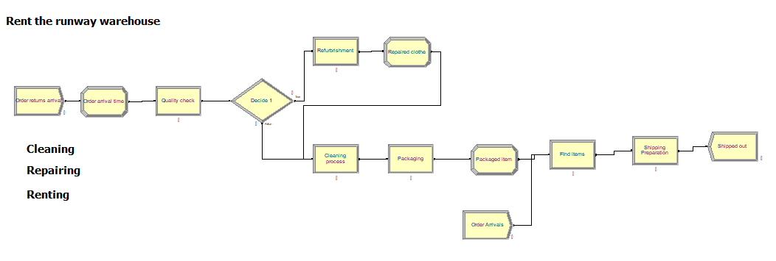

# Input Analysis

The facility operates for 24 hours from Monday to Saturday, 6 days a week. They spent 30 seconds average per item in the quality check section. Nearly 50% of garments return with stains that require hand treatment. The 50 % of the returned item arrived is shipped on the same day. The data source for this project is from their official website and the CEO interview from the news.

# References

Rent The Runway, “How it works”, Retrieved from:

<https://www.renttherunway.com/how_renting_works>

Steven Bertoni, 2014, Forbes, “ The Secret Mojo Behind Rent The Runway’s Rental Machine”, Retrieved from:

<https://www.forbes.com/sites/stevenbertoni/2014/08/26/the-secret-mojo-behind-rent-the-runways-rental-machine/#6ff97d4438bf>

Bianca Herron, 2017, Supply Chain World, “Rent the runway”, Retrieved from:

<http://www.scw-mag.com/sections/retail/868-rent-the-runway>

Jason Del Rey, 2019, Vox, “Rent the Runway Customers are reporting horror stories of cancelled dress deliveries and customer service breakdowns”, Retrieved from:

<https://www.vox.com/recode/2019/9/24/20881206/rent-the-runway-delivery-delays-customer-service-wait-times-reserve-unlimited>